




YENEPOYA INSTITUTE OF ARTS, SCIENCE, COMMERCE AND MANAGEMENT A CONSTITUENT UNIT OF YENEPOYA (DEEMED TO BE UNIVERSITY) BALMATTA, MANGALORE

Final Report
ON
Big Data Analytics for Retail Demand

SUBMITTED BY
HARINAND
III BCA
(Data Science & Big Data Analytics)
23BCCDD031

Industry Mentor: Guided By:
Mr.SHASHANK KORRAM SUZANA SHAROL PRABHAKAR




CERTIFICATE

This is to certify that the project report entitled “Big Data Analytics for Retail Demand” is a bonafide record of the project work carried out by HARINAND.A (Register No: 23BCCDDO31) in partial fulfillment of the requirements for the award of the degree of Bachelor of Computer Applications from Yenepoya Institute of Arts, Science, Commerce and Management, a constituent unit of Yenepoya (Deemed to be University), Mangalore, during the academic year 2025–2026.

Ms. SUZANA SHAROL PRABHAKAR Head of Department
Internal Guide Department of Computer Science

Internal Examiner External Examiner




DECLARATION

I, HARINAND.A, hereby declare that the project report entitled “Big Data Analytics for Retail Demand” submitted to Yenepoya (Deemed to be University), Mangalore, in partial fulfillment of the requirements for the award of the degree of Bachelor of Computer Applications, is an original record of work done by me under the supervision of Ms SUZANA SHAROL PRABHAKAR (Internal Guide) and Mr. Mr.SHASHANK KORRAM (Industry Mentor).
I further declare that the work presented in this report has not been submitted previously, in part or in full, for the award of any other degree, diploma, fellowship, or similar title to any other university or institution.

Place: Mangalore HARINAND.A
Date: __________ (23BCCDD031)




Table of Contents

Executive Summary 6
1.Background 4
  - Aim 4
  - Technologies 5
  - Hardware Architecture 5
  - Software Architecture 5
- System 6
  - Requirements 6
    - Functional requirements 6
    - User requirements 6
    - Environmental requirements 6
  - Design and Architecture 6
  - Implementation 7
  - Testing 7
  - Graphical User Interface (GUI) Layout 7
  - Customer testing 8
  - Evaluation 8
- Snapshots of the Project 9
- Conclusions 13
- Further development or research 14
- References 15
- Appendix 16




EXECUTIVE SUMMARY

The Problem in Retail
Retail businesses generate large volumes of sales data every day, but much of this data is not properly analyzed. Many companies rely on basic reports, making it difficult to identify demand patterns. This leads to problems such as overstocking, stock shortages, and poor decision-making.
The Data-Driven Solution
This project introduces a Retail Demand Analysis System that transforms raw sales data into useful insights. Instead of manual analysis, the system uses Python, SQL, and visualization tools to process and analyze the data efficiently.
How the System Works
The system follows a simple process:
- Load data from CSV files
- Clean and preprocess the data
- Store data in SQLite database
- Perform analysis using SQL queries
- Generate graphs for trend analysis
Key Project Outcomes
- Efficient data processing and cleaning
- Identification of demand trends
- Clear visualization of sales patterns
- Support for better business decisions
Overall, the project demonstrates how data analytics can improve retail performance by providing clear and actionable insights.




1. BACKGROUND
Retail businesses generate large amounts of sales data daily, but much of this data is not properly analyzed. Traditional methods such as manual reports and spreadsheets are time-consuming and inefficient for handling large datasets.
With the growth of data analytics, tools like Python, SQL, and visualization techniques help transform raw data into meaningful insights. Retail demand analysis focuses on identifying sales patterns and trends to support better decision-making.
This project applies data analytics techniques to process retail data and generate useful insights for improving business performance.
1.1 Aim
The aim of this project is to develop a Retail Demand Analysis System that analyzes sales data to identify trends and patterns. The system focuses on transforming raw data into meaningful insights using data processing, SQL analysis, and visualization techniques.
It helps in understanding product demand and supports better decision-making in retail operations.
1.2 Technologies
The system is developed using the following technologies:
- Python: Used for data processing and analysis.
- Pandas: Used for data cleaning and transformation.
- SQLite: Used as a database to store and manage data.
- SQL: Used for performing data aggregation and queries.
- Matplotlib: Used for data visualization and generating graphs.
- Jupyter Notebook: Used as the development environment.




1.3 Hardware Architecture
The system is designed to operate on standard computing hardware without requiring specialized or high-end infrastructure. It can run efficiently on a typical laptop or desktop system equipped with a multi-core processor and a minimum of 4GB to 8GB RAM.
All data processing, analysis, and visualization tasks are performed using lightweight tools and libraries, which eliminates the need for dedicated servers or GPUs. This makes the system cost-effective and easy to deploy in academic and small-scale environments.
The hardware setup ensures smooth execution of data operations such as loading datasets, running SQL queries, and generating visualizations without performance issues.
1.4 Software Architecture
The system follows a simple and structured architecture consisting of multiple layers that work together to process and analyze retail data.
The data processing layer uses Python and Pandas to clean and transform raw data. The storage layer utilizes SQLite to store the processed data efficiently. The analysis layer applies SQL queries to perform aggregation and extract meaningful insights. Finally, the visualization layer uses Matplotlib to present the data in the form of graphs and charts.
This layered approach ensures that the system is organized, easy to maintain, and efficient in handling data analysis tasks.




2. SYSTEM
This chapter describes the overall structure and working of the Retail Demand Analysis System. It explains the system requirements, design, implementation process, and evaluation methods used in the project.
The system is developed to process retail sales data and convert it into meaningful insights using data analytics techniques. It follows a structured workflow that includes data loading, cleaning, storage, analysis, and visualization.
The system is designed to be simple, efficient, and easy to use. It can handle moderate datasets and provide clear outputs that help in understanding demand patterns and sales trends. The following sections describe the detailed components and working of the system.
2.1 Requirements
This section describes the requirements needed for the development and functioning of the Retail Demand Analysis System. These requirements define what the system should do and the conditions under which it should operate.
The requirements are categorized into functional requirements, user requirements, and environmental requirements.
2.1.1 Functional Requirements
The system must provide the following functionalities:
- Load retail dataset from CSV files.
- Perform data cleaning such as handling missing values and removing duplicates.
- Store the processed data in an SQLite database.
- Execute SQL queries to perform data aggregation and analysis.
- Generate visualizations such as bar charts and line graphs.
- Identify demand patterns and product performance.
- Display results in a clear and understandable format.




2.1.2 User Requirements
The system should be simple and easy to use, allowing users to analyze retail data without requiring advanced technical knowledge. Users should be able to load datasets, view processed results, and understand insights through clear visualizations.
The system should provide outputs in an organized and readable format, making it easier for users to identify trends and patterns. It should also be reliable and responsive while handling data operations.
2.1.3 Environmental Requirements
The system requires a standard software environment for execution. It needs Python installed along with required libraries such as Pandas and Matplotlib. SQLite is used as the database, and SQL is used for data querying and analysis.
The project can be developed and executed using tools like Jupyter Notebook or Visual Studio Code. It runs on common operating systems such as Windows, macOS, or Linux without requiring any special configuration.
2.2 Design and Architecture
The system is designed using a structured data pipeline to process and analyze retail data. It consists of different layers that work together to convert raw data into meaningful insights.
The process starts with loading data from CSV files, followed by data cleaning and transformation using Python and Pandas. The processed data is then stored in an SQLite database for efficient management.
SQL queries are used to perform data analysis and aggregation, while Matplotlib is used to generate visualizations. This layered design makes the system simple, organized, and easy to maintain.




2.3 Implementation
The system is implemented using a step-by-step process for data analysis. The dataset is first loaded from CSV files using Pandas, followed by data cleaning to handle missing values and remove duplicates.
The processed data is stored in an SQLite database, where SQL queries are used to perform analysis such as calculating sales and identifying demand trends. Finally, Matplotlib is used to generate graphs for better visualization of the results.
2.4 Testing
The system is tested to ensure that all components work correctly and produce accurate results. Data validation is performed to check for missing or incorrect values, and the outputs of SQL queries are verified for correctness.
The generated visualizations are also checked to ensure that they clearly represent the data. Overall, testing confirms that the system functions properly and provides reliable results.
2.5 Graphical User Interface (GUI) Layout
The system uses a simple and user-friendly interface developed using Jupyter Notebook. The interface allows users to load datasets, view processed data, and analyze results easily.
Tables and graphs are displayed clearly within the notebook, making it easy to understand trends and patterns. The layout is designed to be simple and readable, ensuring that users can interact with the system without any difficulty.




2.6 Customer Testing
In this project, customer testing is considered in terms of usability and result interpretation rather than real user deployment. Since the system is focused on data analysis, testing is performed by evaluating how easily the results can be understood.
The outputs such as tables and graphs are checked to ensure they clearly represent sales trends and demand patterns. This helps in verifying that the system provides meaningful insights that can be easily interpreted for decision-making.
2.7 Evaluation
The system is evaluated based on its ability to process retail data accurately and generate meaningful insights. The outputs obtained from SQL queries are verified to ensure correctness, and the data cleaning process is checked to confirm that missing values and duplicates are handled properly.
The system successfully analyzes sales data to identify important patterns such as product demand, category-wise performance, and sales trends over time. The generated visualizations clearly represent the data, making it easier to interpret and understand.
Performance-wise, the system runs efficiently on moderate-sized datasets without noticeable delays. The overall results demonstrate that the system is reliable, accurate, and useful for retail demand analysis and decision-making.




3. SNAPSHOTS OF THE PROJECT
This section presents the screenshots of different stages of the Retail Demand Analysis System. These snapshots demonstrate data loading, processing, analysis, and visualization steps carried out during the project.
🔹 3.1 Snapshot 1 – Dataset Overview
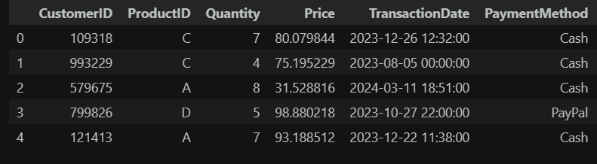

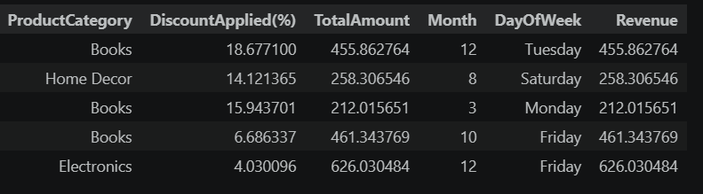




🔹 3.2 Snapshot 2 – SQL Query Output
The data is analyzed using SQL queries (or Pandas operations) to calculate total revenue for each product category. This helps in identifying which categories contribute the most to overall sales.
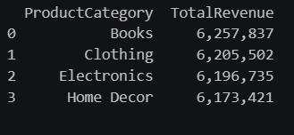

🔹 3.3 Snapshot 3 – Category-wise Sales Graph
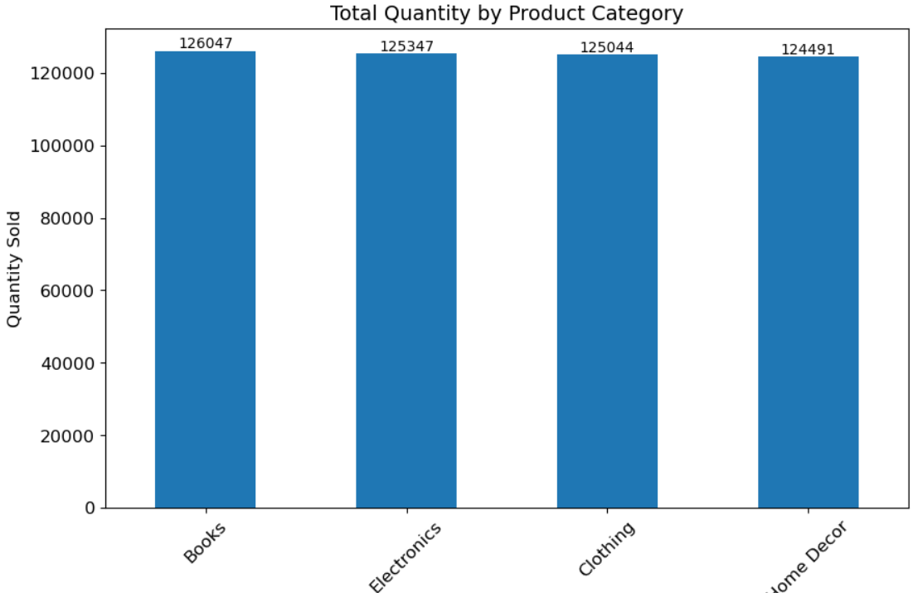
The analyzed data is visualized using a bar chart to represent total revenue for each product category. This graph helps in identifying which categories have higher demand and contribute more to overall revenue.



🔹 3.4 Snapshot 4– Monthly Sales Trend
A line chart is used to display the sales trend over different months. This helps in understanding how sales vary over time and identifying any seasonal patterns.
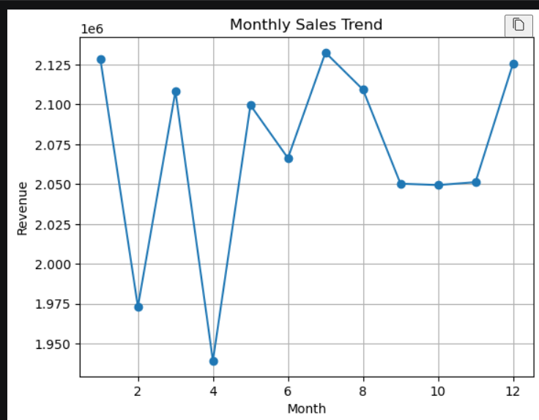



🔹 3.7 Snapshot 5 – Payment Method Distribution
This graph shows the distribution of different payment methods used by customers. It helps in understanding customer preferences in payment options during transactions.
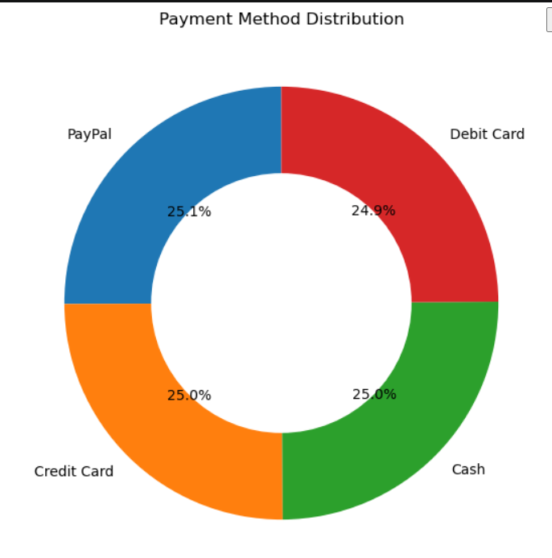

🔹 3.6 Snapshot 6 – Sales Distribution by Country
This donut chart represents the percentage distribution of total sales across different days of the week. It shows how sales are spread from Monday to Sunday, helping in identifying daily demand patterns in retail transactions.
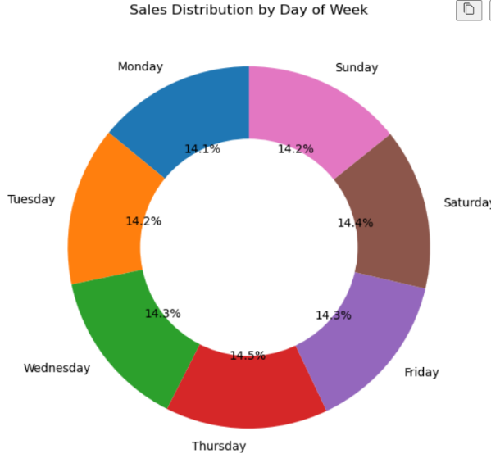




4. CONCLUSIONS
System Overview
The Retail Demand Analysis System successfully demonstrates how data analytics can be used to transform raw retail sales data into meaningful insights. The system follows a structured approach that includes data cleaning, processing, analysis, and visualization.
Key Findings
The analysis of the dataset helped in identifying important patterns such as product demand, customer segment contribution, and sales trends over time. These findings provide valuable insights into customer behavior and business performance.
Visualization and Interpretation
The use of graphical representations such as bar charts, line graphs, and distribution charts makes it easier to understand complex data. These visualizations improve clarity and help in better interpretation of results.
System Performance
The system performs efficiently on moderate-sized datasets without requiring advanced hardware. It provides accurate and consistent results, making it reliable for retail data analysis.
Final Outcome
Overall, the project achieves its objective by developing a simple, efficient, and user-friendly system. It highlights the importance of data-driven decision-making and demonstrates how analytics can support better planning and business strategies in the retail domain.




5. FURTHER DEVELOPMENT OR RESEARCH
Improved Data Analysis
Future work can include more advanced data analysis techniques such as predictive modeling and trend forecasting. This would help in predicting future demand rather than only analyzing past data.
Integration with Dashboard Tools
The system can be enhanced by integrating with visualization tools such as Power BI or Tableau. This would allow the creation of interactive dashboards for better user experience and real-time analysis.
Real-Time Data Processing
Currently, the system works with static datasets. Future improvements can include real-time data processing to analyze live retail transactions and provide instant insights.
Scalability Enhancement
The system can be extended to handle large-scale datasets using big data technologies. This would improve performance and allow the system to be used in enterprise-level applications.
User Interface Development
A web-based or application-based interface can be developed to make the system more interactive and accessible to non-technical users.




6. REFERENCES
- Pandas Documentation – https://pandas.pydata.org
Used for learning data cleaning, transformation, and handling datasets efficiently.
- Matplotlib Documentation – https://matplotlib.org
Referenced for creating graphs and visualizing data in the project.
- SQLite Documentation – https://www.sqlite.org
Used for understanding database operations and data storage.
- W3Schools SQL Tutorial – https://www.w3schools.com/sql
Used for learning basic SQL queries such as SELECT, GROUP BY, and aggregation functions.




7. APPENDIX
This section contains the supporting materials used in the project, including sample code and queries applied during the analysis.

A. Sample Python Code
The following Python code is used for data loading, cleaning, analysis, and visualization:
import pandas as pd
import matplotlib.pyplot as plt

df = pd.read_csv("retail_dataset_clean.csv")

df.dropna(inplace=True)

data = df.groupby("ProductCategory")["TotalAmount"].sum()

data.plot(kind="bar")

plt.title("Category-wise Sales")
plt.xlabel("Product Category")
plt.ylabel("Total Sales")

plt.show()




B. Sample SQL Query
The following SQL query is used to calculate total sales by product category:
SELECT Product_Category, SUM(Total_Amount) AS Total_Sales
FROM sales
GROUP BY Product_Category;
C. Dataset Sample
A small portion of the dataset used in this project is shown in the snapshots section for reference.

